K. J. Somaiya College of Engineering, Mumbai-77
(Autonomous College Affiliated to University of Mumbai)
Semester Long Internship at Reliance Industries Limited
Submitted at the end of semester VIII in partial fulfillment of requirements for the degree of

Bachelors of Technology
by
Sujay Torvi

Roll No.: 1821024
Mentor
Prof. Gopal Sonune
Mr. Suyash Tiwari



Department of Computer Engineering
K. J. Somaiya College of Engineering, Mumbai-77
(Autonomous College Affiliated to University of Mumbai)

Batch 2017 -2021
Batch 2017 -2021
K. J. Somaiya College of Engineering, Mumbai-77
(Autonomous College Affiliated to University of Mumbai)

Certificate

This is to certify that the Internship report entitled Semester Long Internship at Reliance Industries Limited completed at Reliance Industries Limited during January – May 2021 submitted by Sujay Torvi at the end of semester VIII of LY B. Tech is a bona fide record for partial fulfillment of requirements for the degree of Bachelors in Technology in Computer Engineering of University of Mumbai.


Internship Internal Mentor Internship External Mentor

___________________
Head of the Department

_________________
Principal
Date:
Place: Mumbai-77

K. J. Somaiya College of Engineering, Mumbai-77
(Autonomous College Affiliated to University of Mumbai)

Certificate of Approval of Examiners

We certify that this Internship report entitled Semester Long Internship at Reliance Industries Limited is bona fide record of internship work done by Sujay Torvi during semester VIII.
This internship work is submitted at the end of semester VIII in partial fulfillment of requirements for the degree of Bachelors in Technology in Computer Engineering of University of Mumbai.

___________________________
Internal Mentor

External/Internal Examiners

Date:

Place: Mumbai-77
K. J. Somaiya College of Engineering, Mumbai-77
(Autonomous College Affiliated to University of Mumbai)

DECLARATION
I declare that this written internship report submission represents the work done based on our and / or others’ ideas with adequately cited and referenced the original source. I also declare that I have adhered to all principles of intellectual property, academic honesty and integrity as we have not misinterpreted or fabricated or falsified any idea/data/fact/source/original work/ matter in my submission.
I understand that any violation of the above will be cause for disciplinary action by the college and may evoke the penal action from the sources which have not been properly cited or from whom proper permission is not sought.

______________________________
Signature of the Student

_______________________________
Roll No. 1821024

Date:
Place: Mumbai-77

K. J. Somaiya College of Engineering, Mumbai-77
(Autonomous College Affiliated to University of Mumbai)

Internship Completion Certificate
(Certificate received by Organization can be attached here)

Abstract
Reliance Industries is a conglomerate organization having several businesses. Founded by Dhirubhai Ambani and currently headed by Mukesh Ambani, it is one of the largest corporate institutions in India. One of their businesses, hydrocarbons offers variety of products such as polymers, polysters, etc. One of the part of this business is PetChem. The IT Division of Petchem Business builds systems for the business in order to efficiently manage the data. The internship focuses on contributing to a project named “Petchem Data Management”, which solves the problem of manual dependency to update the flowing data, while ensuring that no activity is unauthorized in any manner or form and allows for logging of every activity so that it can be audited regularly. This Internship allows me to learn new skills and apply existing skills in software development especially web development.

Table of Contents

List of Figures
List of Tables
1 | Introduction |  |  | 1
 | 1.1 | Background of Industry |  | 1
 | 1.2 | Motivation |  | 1
 | 1.3 | Scope of the internship |  | 3
 | 1.4 | Brief description of work undertaken |  | 4
2 | Concept of the Internship |  |  | 5
 | 2.1 | Internship Objectives |  | 5
 | 2.2 | Internship Methodology |  | 5
3 | Flow diagram / Methodology |  |  | 6
 | 3.1 | Introduction |  | 6
 | 3.2 | Problem Statement |  | 7
 |  | 3.2.1 Scope of the system |  | 7
 | 3.3 | System Requirements |  | 8
 |  | 3.3.1 Hardware Requirements |  | 8
 |  | 3.3.2 Software Requirements |  | 8
 | 3.4 | System Design |  | 9
 |  | 3.4.1 System Architecture |  | 9
 |  | 3.4.2 System Modules |  | 9
 |  | 3.4.3 Use Case Diagram |  | 10
 |  | 3.4.4 Workflow / Flow Chart |  | 11
4 | Implementation and experimentation |  |  | 12
 | 4.1 | Software Development Life cycle |  | 12
 | 4.2 | Internship Timeline |  | 13
 | 4.3 | Techno | logies Implemented in Learning Project | 14
 | 4.4 | Technologies Implemented in Internship Project |  | 14
5 | Key learnings from the Internship |  |  | 15
 | 5.1 | Technical Learning |  | 15
 | 5.2 | Non-Technical Learning |  | 16
5 | Results and conclusions |  |  | 17
 | 5.1 | Significance of courses learnt during engineering program |  | 17
 | 5.2 | Results and Discussion |  | 18
 | 5.3 | Conclusion |  | 19
 | 5.4 | References |  | 19

List of Figures:

- Fig 3.1 System Architecture 9
- Fig 3.2 Use Case Diagram 10
- Fig 3.3 Flow Diagram 11
- Fig 4.1 Agile Model 12
- Fig 4.2 Internship Timeline 13

List of Tables:
- 6.1 Significance of courses learnt during Engineering Program 17

Chapter 1
Introduction and Motivation

  - Background of Industry

Reliance Industries Limited (RIL) is an Indian multinational conglomerate company founded by Shri Dhirubhai Ambani and currently headed by Shri. Mukesh Ambani, headquartered in Mumbai, India. Reliance owns businesses across India engaged in energy, petrochemicals, textiles, natural resources, retail, and telecommunications. Hydrocarbons, one of the business of RIL, is the one of the largest producer of hydrocarbons in the country, and amongst the top ten in the world. It produces a variety of Products such as Polymers, Polyesters, Elastomers, Fibers, etc. Petchem, being an abbreviation for the term petrochemicals is one part of this business. The department collects lot of data generated by the business, and to maintain that data, has set up an IT Division where different teams create internal organizational software as per requirement and perform maintenance and upgradation of old software.

  - Motivation

The main motivation for the internship is to ensure smooth transition from the academia to the industry after graduation. Students often struggle to adjust to the new corporate environment after they come out of their engineering course. Many students are not able to intern in industries, due to the heavy workload of the engineering curriculum, and even if they are able to intern, it is only for a couple of months which is not enough to build momentum and prepare the engineer’s mind for the industry. Thus Semester Long Internship provides that momentum that allows me to enter the industry with confidence, and even if the technology stack or domain of the software changes, it rarely matters, since the software engineering process remains the same, and the important business and soft skills are used everywhere regardless the nature of work.

Some of the reason why students struggle during transition from academia to industry:

- In the final year/semester of the students, the project is simply a part of the engineering curriculum, which means that students have to study other subjects along with the project, which includes assignments and term tests for the subjects. Due to this, the effort gets divided between theory subjects and the project, and thus students are not mentally prepared to work on a single project for whole workday attending meetings alongside. Thus industries give training to the freshly joined employees to make them accustomed to this. However, Semester long Internship Removes this barrier, by relieving us from attending lectures and various continuous assessment components that are required for theory subjects and allows the students to directly attend the end semester examination(ESE).

- In engineering final year projects, students, who are doing software projects, do not apply latest industry software engineering practices such as agile or scrum models. One of the reasons maybe due to that the problem at hand is not complex and large enough to apply these models and thus students apply simple models such as incremental model, waterfall model, etc. However, in industries, business problems are complex and also need to be scalable in the future. Keeping these things in mind, agile or scrum or similar practices are applied. Since the student is acquainted about this practices only theoretically, he or she is not able to adapt to the practices used in the industry and thus needs training in order to adapt to the process. Semester Long Internship allows us to involve in these practices through internship in the industry and thus makes us more capable than other students in this area.

Other personal motivations include:
- Interviews for full time jobs are much more rigorous as there is much stake for the organization, thus it becomes hard to get selected in the companies, given how there is rampant growth of unemployed engineers in the country. Interviews for internships are much simpler and it is relatively easy to secure an internship. From the perspective of the industry it makes more sense to recruit after seeing the performance of the intern, since it is inexpensive to keep the intern and easily judge whether the student is fit as an employee for the organization.

Similarly, from the perspective of the student, it makes much more sense to easily get an internship and later get absorbed as a full time employee, than attending job interviews hither and tither, and having low chances of getting a job

Due to above reasons, semester long internship would benefit to my career and thus this makes it worth applying for.

  - Scope of the Internship

The nature of the internship is that of a full stack development. The responsibilities include:

- Learn the technology stack (Angular, Java Spring Boot, MySQL )while the project is in the design phase, and this learning continues even after core concepts are learnt, while applying the skills for completing tasks/deliverables.

- Attend project progress meetings and suggest solutions for solving sub-problems of the project.

- Finish the tasks/deliverables for the frontend / backend of the project assigned by the industry mentor and give regular updates of the progress.

- Test the deliverables of other team members and report bugs to the mentor. Fixing the bug if possible (which becomes another deliverable). Testing includes but not limited to user acceptance testing, negative testing, validation testing, white-box testing and black-box testing.

- Perform Documentation of the software.

  - Brief Description of the work undertaken

I am a part of one of the Teams at Petchem IT division working at a project titled “Petchem Business Data Management”. As an intern, I have to collaborate with other team members, who are full time employees, for the development of the project. The project stack includes the following components:

- Angular Framework for Frontend
- Java Springboot for Business Logic
- MySQL for data storage

Brief details of the nature of the tasks given to me as follows:
- Test a particular page and trace the bug. The component maybe developed by a different team member. If possible locate the typescript or Java code routine that is causing the bug and fix it, and push the updated code to the repository.

- Preparing Standard operating procedure and other documentation including but not limited to such as documenting test cases for pages that are tested for future reference, presentation slides, etc.

- Perform User Acceptance Testing.

- Assisting people from other development teams, who have come for User Acceptance Testing, acting as a first line of support for UAT testers.

Chapter 2
Concept of the Internship

2.1 Internship Objectives
The objectives of the internship are the following:

- To learn different technologies related to full stack development and update my skillset.
- To learn agile methodology and apply it practically in real time
- To learn how to communicate and collaborate with the team
- To prepare the mind to work 8 hours a day, without being exhausted, and become more confident to take up challenging tasks.
2.2 Internship Methodology

At Reliance Industries Limited, they perform the following to ensure maximum learning for the intern:

- Onboard the intern, and make the intern acquainted with the environment. A project for the intern is identified, only those which are at a planning and analysis phase, so that the student learns all the phases of software development life cycle (SDLC).

- While the problem statement is still being discussed, the intern has to attend the meetings and give his or her valuable suggestions for the improvement of the project design. During this phase the intern is given some material to learn the technology. For 1 – 1.5 months the intern learns the technology and is given some learning project to do, so that it reinforces learning by doing. During this period, a mentor from the team is assigned who will guide the intern properly.

- After the learning project is over, the intern can return back to the main project, joining the ongoing sprints. At this phase the intern is assigned deliverables by the mentor (development, testing, documentation tasks), and the progress of the deliverable is regularly reported to the mentor.
Chapter 3
Flow diagram / Methodology

3.1 Introduction

Reliance Industries Limited collects and maintains a lot of data for its PetChem Business. This data is utilized in various ways:

- Make quarterly / yearly reports of the data
- Maintain records for Audit
- Use data for Business Intelligence purposes: Such as data analysis, visualization, prediction, etc.
And many other ways.

Currently the organization is facing a few challenges regarding the data:

- Data is continuously flowing on a regular basis. The data is primarily captured in the form of excel sheets.

- This data has to be mapped in visualization tools & analytics for business intelligence.

- Contents of the data change and has to be frequently updated

- Ownership of data lies only with the business owner as per the organizational norms and rules. Due to dependency on IT Team it is an overhead

- There is no system which after having owner approval automates the process of data updation, in a fast and seamless manner, thus optimizing the overall process.

  - Problem Statement

The system named “Petchem Business Data Management”, suggested by the Petchem IT Team, solves the above problem, by allowing the user to submit use cases (which are essentially the data description), to the business owner, and after approval, the user can upload data, which gets updated in the database.

Thus the objective is to get the data in the system for analytics and for other purposes in an automated fashion and reduce dependency on manual labor

Users of the System:
- User of use case: RIL Employee working in data / BI / Any other group of Petchem Department, who wishes to create a new use case and get it approved for his work.
- L1 User: Immediate Reporting Managers of employee user
- IT Admin: IT Head for particular division.
- Business Data Owner: Head in charge for that particular business is the Business Data Owner.
Roles are specific to a use case. A person using the software may act as a use case user for one use case or an approver
    - Scope of the system
Following are the objectives of the system:
- Allow a user to submit use cases to the system
- User can decide who can read the data, edit the data, etc. By Default, the business owner is read only user of the use case

- User can upload template excel sheet with or without data, and the system fetches the column names automatically along with their data type. User is free to change the data type as well as whether a column will be key or not null.

- Following is Decided to be the approval chain of the system:
Use case Submitted => L1 Approval => IT Admin Approval => Business Data Owner Approval=> Use case created

- Users will be able to track the use case status. The approvers will know the use cases that are pending under them. They can approve the use case, reject or send it back to the user for further changes.

- After the approval, the user can now upload data to the use case, through excel sheet (xls or xlsx). The excel sheet needs to be validated and then gets uploaded.

- The user should able to search data in the use case and able to download required data in the form of excel sheet.

- Every activity is to be logged for audit purposes.

  - Project Requirements
    - Hardware Requirements

- The software is going to be deployed on the intranet, on kubernetes nodes.
- To access the system, the user be connected to RIL Intranet and navigate to the appropriate URL once it is hosted.
    - Software Requirements
- The system is a web application with the software stack adhering to standards of the organization:

- Frontend Framework: Angular 9
- Business Logic: Java Spring Boot (with embedded tomcat)
- Database: MySQL
- Tools / Editors / IDEs Used: VSCode, Spring Tool Suite (STS), GIT CLI

Organization has Azure DevOps system, where code can be pushed to repositories, and is also used to assign deliverables, keep track of deliverables, and other SDLC Functions.

  - Project Design
    - System Architecture:

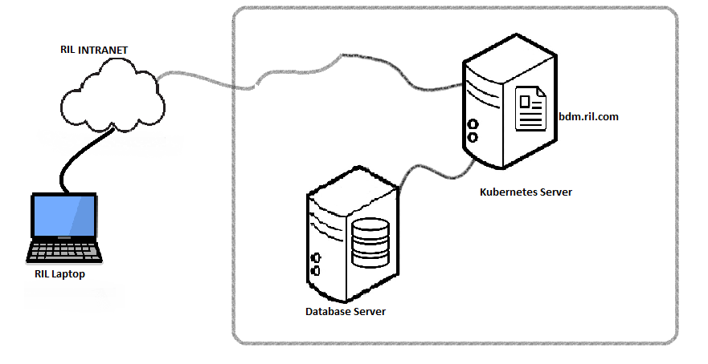
Fig 3.1 System Architecture

3.4.2 System Modules
The system has following modules:
1. Login: User SSO Login / LDAP Credentials

2. Landing Page: A Dashboard Where users can see pending usecases, add new usecases, see approved usecases where data can be uploaded.

3. Add New Usecase: For adding new usecases.

4. Use case approval: For reviewing requests and approving/rejecting them

5. Approval List: Check status of submitted usecases.

6. Use Case: For viewing data in the use case, searching it, downloading data, uploading new data, etc.

7. Manage users: Managing users who are allocated to particular use case

3.4.3 Use Case Diagram
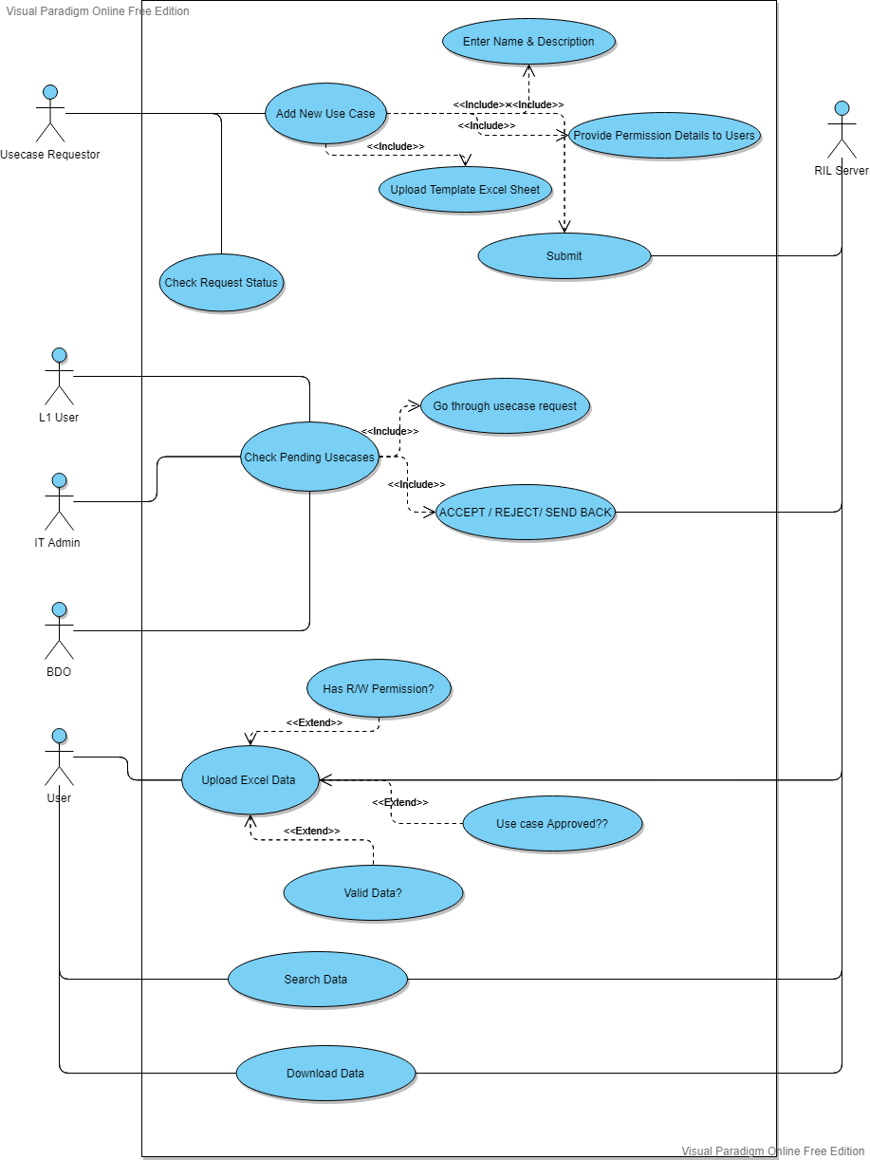

Fig 3.2 Usecase Diagram
3.4.4 Flowchart/Workflow of System
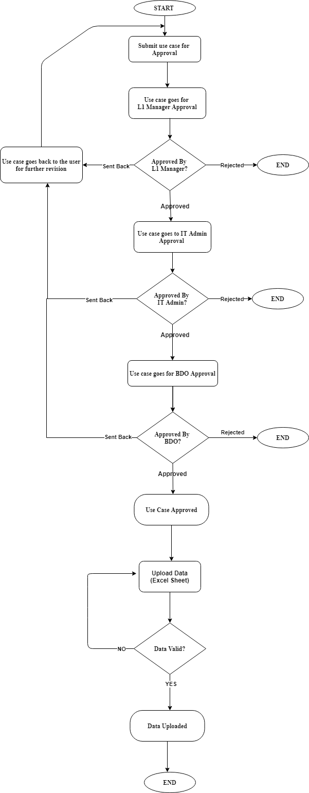
Fig 3.3 Flowchart
Chapter 4
Implementation and experimentation

4.1 Software Development Lifecycle Model
Agile Model: Scrum
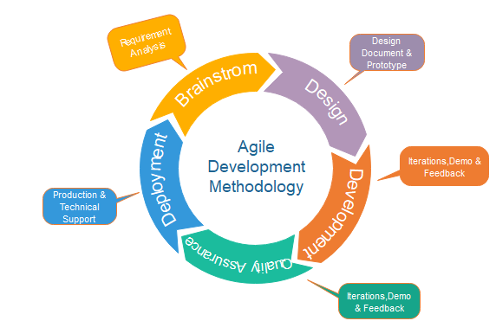
Fig 4.1 Agile Model
The IT Team of Petchem Department of RIL uses Agile modeling for its software development lifecycle.

Each sprint here lasts for about 2 working weeks.
- During these time deliverables were assigned to me.

4.2 Internship Timeline
Following is the timeline of my internship along with gantt chart.

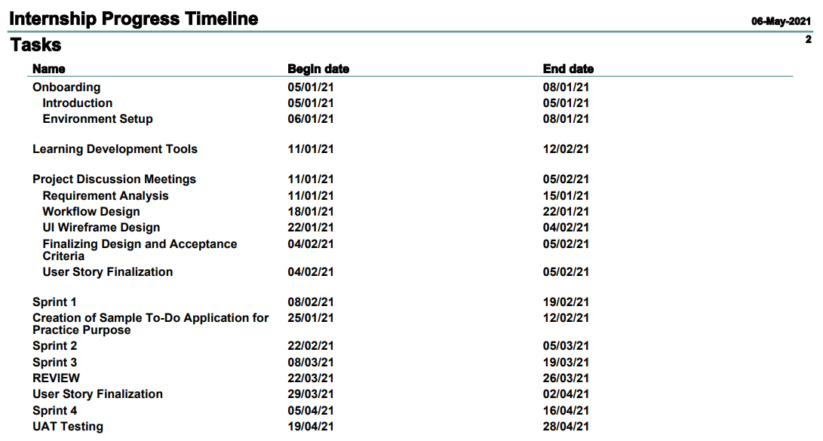

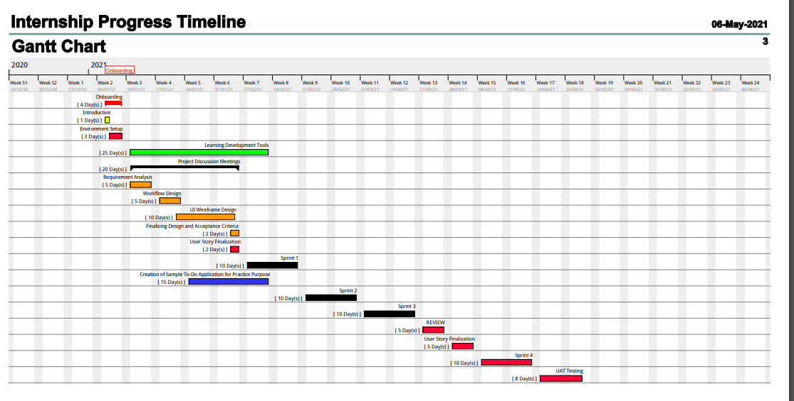
Fig. 4.1 Internship Timeline

4.3 Technologies Implemented in Learning Project:

During the initial stages of the internship a learning project was assigned to me which is making a to-do application. In that application I implemented the following:

Angular: Angular concepts such as directives (ng-model, ngIf, etc), angular services, angular routing, how to connect angular with springboot, etc.

SpringBoot: I applied concepts such as creating a repository of a table, creating microservices, creating controllers, etc.

4.4 Technologies Implemented in Internship Project

So far in the internship, when the development began in Mid-February, my contribution has been mainly focused on angular and css. Applied the knowledge gained in making the learning project to create minor functionalities, identify bugs and assist the team members in fixing them.

Chapter 5
Key learnings from the Internship

5.1 Technical Learning
The following is the list of things I learnt that add to my technical skill set

- Sharpened my web development skills: Working has sharpened my skill set in the css and angular framework.

- Learnt a new framework: Spring Boot: This Internship allowed me to learn a new Java Framework called spring boot which is a standard for enterprise application as it is very secure, and easy to maintain. The concept of micro services was introduced to me where we can create services that serve different modules of our project instead of adding redundancy of code in the modules.

- Introduced me to Functional Programming: Refers to my habitual coding practices in my engineering assignments, where I used to code every logic from scratch. However, I was guided by my mentor to learn functional programming, by looking up documentations of the frameworks we were using, because:
- It helps to save time
- Makes code more readable
- Uses more optimized routines than the one we create when we code from scratch

- Version Control Tools: In the courses I was taught how to use GIT, however in reality I never used it for any of my projects. In the internship I had to revise and refresh my knowledge of GIT Client so that I could resolve code conflicts. Thus I have more confidence while using version control tools.

- Taught me the Importance of writing Optimized and Secure code:
I had some knowledge of optimization of algorithms. However, it was still fine if we could write slightly sub-optimal code and as long as we got output quickly, it would be fine. However, while writing code for enterprise applications, not writing optimized code will make your application slow, although it may appear fast while testing on short amounts of dummy data, the sub-optimality of the code will show its effects on real large amounts of data. Since the application is always made to be scalable in the future, all code has to be as optimized as possible.

Secure code is also very important as privacy of enterprise data is of paramount importance. My mentor mentioned that at RIL, they have a QA Team which will run automated tools on the application code and send the application for corrective changes.

- Testing: Gave me firsthand experience on the following types of testing – Validation Testing, Negative testing and most importantly User Acceptance Testing.

- Documentation: Learnt how to write standard operating procedure for industry systems.

5.2 Non – Technical Learning
- Team collaboration skills: This internship taught me how to be a team player in the corporate environment.

- Ability to work under pressure: How to deliver when there is a deadline. Although this comes with experience, the experienced gained in the internship is a good start.

- Communication Skills: How to speak up in a meeting of some people and give up your suggestions and opinions without fearing that your point may get rejected. Thus attending such meetings brings more confidence as time goes by.

Chapter 6
Results and Conclusions
This chapter concludes the report with the final results of the internship, and future work. It also talks about the significance of courses taught in college that have helped me during the internship.
6.1 Significance of Courses undertaken during Engineering
 | Course Name | Semester |  |  | Significance
 | Web Technology | 5 |  |  | First learnings on how to create a web page, and work with css, html, etc. Also introduced me to angular.
 |  |  |  |  | Foundation for learning JAVA , and OOP concepts which allowed me to learn new concepts such as AOP, and other related concepts of java springboot framework.
 | Object Oriented Programming & Methodology | 3
 |  |  |  |  | This was a foundational course for understanding how
 | Relational Database | 4 |  |  | relational databases are designed and used. The
 | Management Systems | 4 |  |  | learnings from this course are applicable in my day-
 |  |  |  |  | to-day activities at RIL.
 |  |  |  |  | Introduced me to concepts such as Version Control, etc.
 | Open Source Lab | 6

Table 6.1 Significance of courses

Software Engineering course of Semester 5 has also contributed a lot to me without which I would be unaware of the software practices such as agile scrum methodology and other practices used in the industry.

6.2 Results and Discussion
Thus we saw how a business problem is approached, solved and optimized in the industry. The first few days allowed me to onboard with the team and adjust to the new environment. The learning of the technologies refreshed my existing knowledge about web and development as well as new concepts never seen before. The technical solution defined by the team at Petchem shows how a business problem is translated to a real life solution. Thus contributing to such a system allows me to not only learn the technology but also how to satisfy the client’s needs.

6.2 Conclusions

System that is defined is ever evolving and changes over time. Thus there is a continuous thinking of requirements and optimizing them to solve the needs.

Thus this internship gives me a wholesome experience by offering me technical skill learning as well as imparting the necessary soft skills. I understood how the process of solving a business problem works in the industry and how the solution is optimized in real time. This would add a lot to my engineering experience and will give me a good head-start to my career.

I would like to thank the KJSCE Committee for coming up with the Semester Long Internship scheme and the stakeholders at RIL giving me the opportunity for the internship and allowing me to get work experience.

6.3 References

Following are the references used for the report:

- https://en.wikipedia.org/wiki/Reliance_Industries
- https://www.ril.com/
- https://www.javatpoint.com/software-engineering-agile-model

